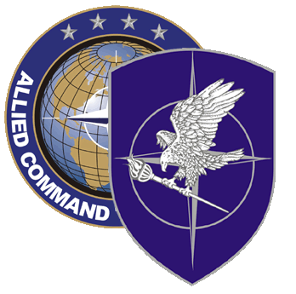
NATO SCHOOL: Global Leader in Multinational Military Education and Individual Training

M7-59 TEST DESIGN AND EVALUATION

This is one of 4 courses offered by NATO School to support the implementation of the NATO Education and Individual Training Management System (NEITMS). The aim of this course is to prepare individuals to build tools to assess student learning, and to effectively conduct the 5th part of the NEITMS Quality Control System function of Evaluation, which is to monitor and improve the effectiveness and efficiency of courses.

Course Length: 1 week

Offerings per year: 2

Class Size: 20 max / 8 min

Security Clearance: NATO UNCLASSIFIED

Rank Limitation: None

Prerequisites:

- Prior completion of M7-49, NEITMS Analysis, Design and Development Course is desirable

- Language proficiency: English IAW STANAG 6001 3333

- Computer skills: Student must be familiar with MS Word and Power Point

Course Objectives:

At course completion, the student should be able to:

- Develop student assessment

- Conduct NEITMS Evaluation

